NIRMAYEE S. KADAM PRN-25070521134 SEC-C1
EX 7.1.1-INVERTED STAR PATTERN

ALGORITHM:
- Input: Receive the number n, which represents the total rows to print.
- Loop: Start a countdown loop that begins at n and decreases by 1 in each step until it reaches 1.
- Pattern Generation: In each step of the loop (for the current value i):
  - Print the character '*' repeated i times.
- Repeat: The loop continues until i reaches 1, creating the inverted triangle effect.

FLOWCHART:
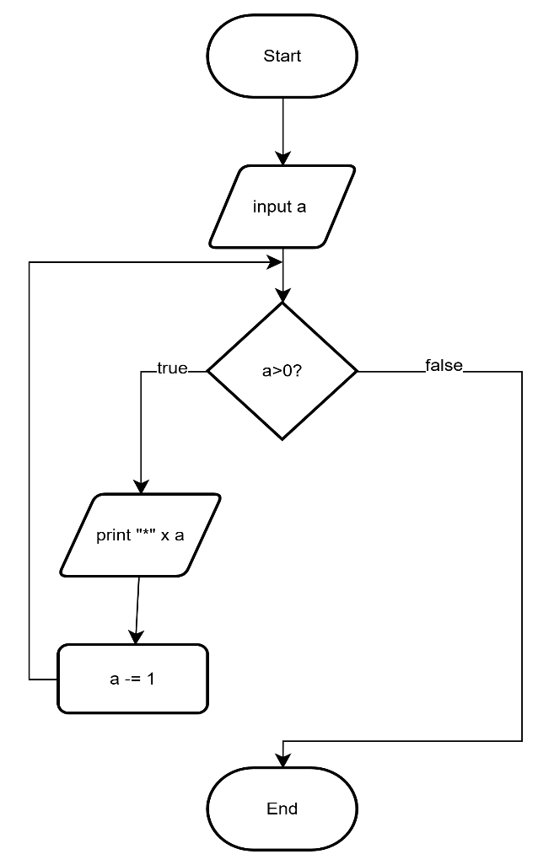

NIRMAYEE S. KADAM PRN-25070521134 SEC-C1

CODE:
